Boolean Equations

- Construct the truth table for the Boolean equation: C=AB’+A’B

Inputs |  | Output
A | B | C
0 | 0 | 0
0 | 1 | 1
1 | 0 | …
1 | 1 | …

- Draw a simple NOT, AND, OR circuit in sum of products (SOP) form that represents the equation above.

- The truth table for a Boolean expression is shown below. Write the Boolean expression on SOP form.
Inputs |  |  | Output
A | B | C | Sum
0 | 0 | 0 | 0
0 | 0 | 1 | 1
0 | 1 | 0 | 1
0 | 1 | 1 | 0
1 | 0 | 0 | 1
1 | 0 | 1 | 0
1 | 1 | 0 | 0
1 | 1 | 1 | 1

Sum=
- Find the truth table that describes the following circuit:

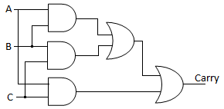
Indication:
Inputs |  |  | Output
A | B | C | Carry
0 | 0 | 0 | 0
0 | 0 | 1 | 0
0 | 1 | 0 | …
0 | 1 | 1 | …
1 | 0 | 0 | …
1 | 0 | 1 | …
1 | 1 | 0 | 1
1 | 1 | 1 | 1

- Having the following circuit:
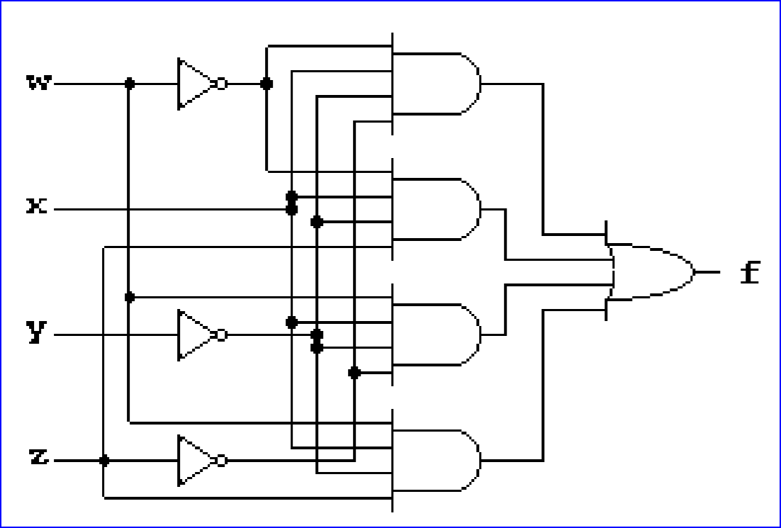
Write the Boolean expression on SOP form of the function f =
Minimize function f
Draw the minimize form of function f.

- Nick, Jackie, William and Heather are members of the board of trustees of a big company. Decisions are made by the following criteria
A buy order is placed if:
- William, Jackie and Heather vote YES, or
- William and Jackie vote YES, or
- Nick, Jackie and Heather vote YES, or
- Jackie and Heather vote YES, or
- William vote YES and Nick and Heather vote NO, or
- Nick and William vote YES, or
- Nick and Jackie vote NO and William and Heather vote YES
Design a simplified switch panel and logic circuits that will make the buy decision for these obviously confused stock brokers. Consider the variables N, W, J, H associated with the brokers, and D with decision.
- Establish the truth table considering YES=1 and NO=0
- Minimize using Karnaugh map
- Write the equation for D-decision in function of the votes of members
- Draw the circuits using AND, OR, NOT gates
Could you see something special in the result?

